Year 5 English Online Learning –Week 7
Before Half Term, you should have completed these sessions to begin thinking about writing the build-up scene:
- Lesson 9 – Generate vocabulary to describe the characters
- Lesson 10 – Explore Complex Sentences
- Lesson 11 - To Plan the first part of the opening scene
- Lesson 12 - Develop a rich understanding of words associated with clumsiness
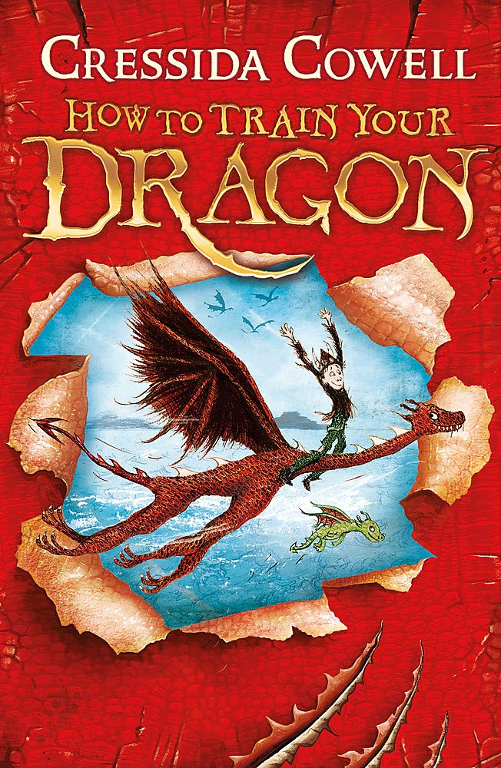
This week, we are going to continue focussing on the build-up scene, which will develop to the problem of the story. You may need to refer back to the notes you made before half term.
For each of these sessions, there is a teaching video to watch (the links are on the next page). The teacher in the video will explain everything to you and will tell you what equipment you will need (normally, this is only a pen/pencil and piece of paper or a notepad you would like to keep all your English work in). You will need to keep your notes and work from each session as you will use these for the final piece of writing. You must pause the video at the points the teacher asks because you will need to make notes/think/talk to an adult about your ideas. Please don’t worry that the numbers on the video do not match with the numbers ion this document. We are not completing the lessons on spellings so our lesson numbers will be different to the website.
Please send pictures of your notes/piece of work to Miss Hutchinson on the Class 5 email. This could be at the end of the day or at the end of the week. Class5@mill-lane.oxon.sch.uk

Monday 22nd February 2021
Lesson 13 – Write the first part of a build-up scene
Optional Writing template available for this writing
https://classroom.thenational.academy/lessons/to-write-the-first-part-of-a-build-up-scene-64r32c
In this lesson, we will write the first section of the build-up of 'How to Train Your Dragon'. You will need your plan from lesson 4 to help you with your writing.
Tuesday 23rd February 2021
Lesson 14 – Plan the second part of a build-up scene

https://classroom.thenational.academy/lessons/to-plan-the-second-part-of-a-build-up-scene-c9gpcc
In this lesson, we will plan the second section of our writing for the build-up scene in the film 'How to Train Your Dragon'.
Wednesday 24th February 2021
Lesson 15 – Write the second part of a build-up scene
Optional Writing template available for this writing
https://classroom.thenational.academy/lessons/to-write-the-second-part-of-a-build-up-scene-6hk38c
In this lesson, we will write the second section of the build up of 'How to Train Your Dragon'. You will need your plan from Lesson 8 to help you with your writing.
Thursday 25th February 2021
Lesson 16 – Edit your build-up writing

https://classroom.thenational.academy/lessons/to-edit-your-build-up-writing-cngk2r
In this lesson, we will edit our writing from Lessons 6 and 9. We will practise the skills of searching for errors and improving vocabulary choices.

