Year 5 English Online Learning – Week 5
Last week you should have completed these four lessons:
- Lesson 1 – An introduction to the text ‘How to train your dragon’
- Lesson 2 – Simple & Compound Sentences
- Lesson 3 – Features of an opening scene
- Lesson 4 – Develop a rich understanding of words associated with water
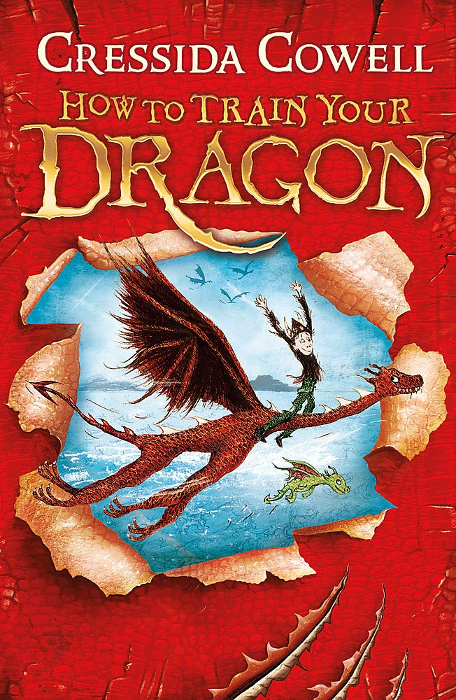
This week, we are carrying on from this learning and building up a description of the opening scene from ‘How to train your dragon’.
For each of these sessions, there is a teaching video to watch (the links are on the next page). The teacher in the video will explain everything to you and will tell you what equipment you will need (normally, this is only a pen/pencil and piece of paper or a notepad you would like to keep all your English work in). You will need to keep your notes and work from each session as you will use these for the final piece of writing. You must pause the video at the points the teacher asks because you will need to make notes/think/talk to an adult about your ideas. Please don’t worry that the numbers on the video do not match with the numbers ion this document. We are not completing the lessons on spellings so our lesson numbers will be different to the website.
Please send pictures of your notes/piece of work to Miss Hutchinson on the Class 5 email. This could be at the end of the day or at the end of the week. Class5@mill-lane.oxon.sch.uk

Monday 1st February 2021
Lesson 5 – Generate adverbs and verbs to describe the opening scene
https://classroom.thenational.academy/lessons/to-generate-precise-adverbs-and-verbs-to-describe-the-opening-scene-6mu30r
In this lesson, we will revise the role of adverbs and focus on the importance of choosing precise adverbs. We will practise this skill and then move on to identify precise verbs and adverbs to describe the action in the opening scene. We will use these verbs and adverbs to write ambitious sentences.
Tuesday 2nd February 2021
Lesson 6 – Plan and write the first part of the opening scene
For this lesson, there is a writing template on the website that the children could use.
https://classroom.thenational.academy/lessons/to-plan-and-write-the-first-part-of-an-opening-scene-6mr30t
In this lesson, we will plan and write the first part of our opening scene. We will review any vocabulary generated in previous lessons and apply this in our writing today.
Wednesday 3rd February 2021
Lesson 7 – Plan and write the second part of the opening scene
For this lesson, there is a writing template on the website that the children could use.
https://classroom.thenational.academy/lessons/to-plan-and-write-the-second-part-of-an-opening-scene-6dgk4r
In this lesson, we will plan and write the second part of our opening scene. We will review any vocabulary generated in previous lessons and apply this in our writing today.
Thursday 4th February 2021
Lesson 8 – Plan and write the third part of the opening scene
https://classroom.thenational.academy/lessons/to-plan-and-write-the-third-part-of-an-opening-scene-6wwp6t
In this lesson, we will plan and write the third part of our opening scene. We will review any vocabulary generated in previous lessons and apply this in our writing today.

