Year 6 English Online Learning – Week 4
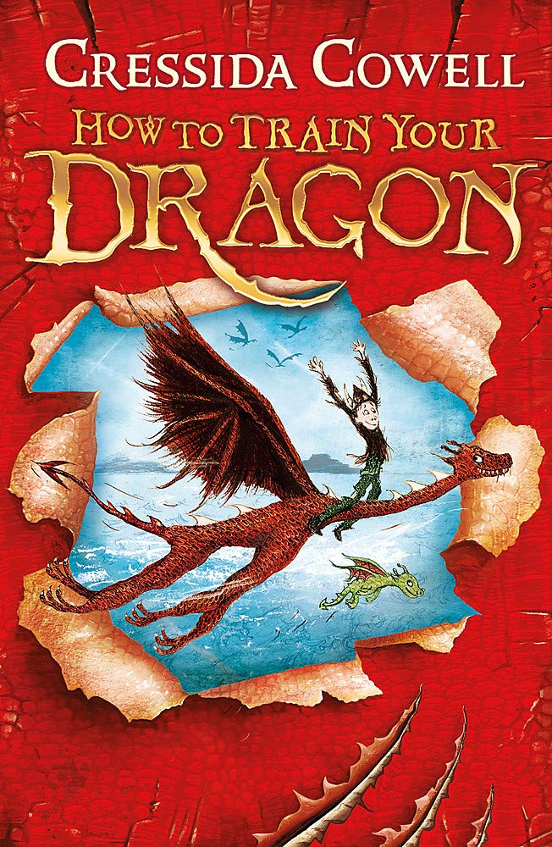
A lot of you will be expecting to start this week off with day 9&10 from the English learning journey booklet we have been working from. However, we decided that a lot of you had already had time to edit your diary entries and we would leave the decision up to you as to whether you would like to spend some of your afternoon time or Friday project time writing or typing up your diaries. We are now moving onto a new online unit themed around the book & film ‘How to train your dragon’ as this links to our Anglo Saxon and Viking topic. We know a lot of you have read this book series but you do not need to have read the books or seen the film before these lessons; the videos show you all that you will need. We hope you like the teaching videos as much as we liked them as they are broken down and very well explained.
For each of the sessions on the next page, there is a teaching video to watch. The teacher in the video will explain everything to you and will tell you what equipment you will need (normally, this is only a quiet space in which to work, pen/pencil and piece of paper or a notepad you would like to keep all your English work in). You will need to keep your notes and work from each session as you will use these for the final piece of writing in lesson 6-8 (next week). You must pause the video at the points the teacher asks because you will need to make notes/think/talk to an adult about your ideas. Please don’t worry that the numbers on the video do not match with the numbers on this document. We are not completing the lessons on spellings so our lesson numbers will be different to the website ones.
Please send pictures of your notes/pieces of work to Mrs Carey on the Class 6 email. This could be at the end of the day or at the end of the week. Class6@mill-lane.oxon.sch.uk
Enjoy and I look forward to hearing what you think on our Teams calls!
Mrs Carey

Monday 25th January 2021
Lesson 1 – An introduction to the text ‘How to train your dragon’
https://classroom.thenational.academy/lessons/to-engage-with-the-context-of-the-how-to-train-your-dragon-narrative-ccvkee
In this lesson, we will learn about the author, setting and key characters in this narrative and visual narrative. We will also learn about the historical context of some of the characters.
Tuesday 26th January 2021
Lesson 2 – Simple & Compound Sentences
(don’t worry that the video says it is lesson 3 – we are not using some of the lessons from this unit as they are about spelling)
https://classroom.thenational.academy/lessons/to-explore-simple-and-compound-sentences-74r3cr
In this lesson, we will explore simple and compound sentences. We will look at what a sentence is and how sentences are made up of clauses and phrases. We will then discuss what a main clause is and how these are used to create simple and compound sentences.
Wednesday 27th January 2021
Lesson 3 – Features of an opening scene
https://classroom.thenational.academy/lessons/to-identify-the-c-and-s-features-of-an-opening-scene-cgup2d
In this lesson, we will explore the opening scene, generating vocabulary to describe the sounds and the setting. We will also use our new vocabulary to begin to write descriptive sentences about the setting.
Thursday 28th January 2021
Lesson 4 – Develop a rich understanding of words associated with water
(this lesson is from another unit but will be really useful for developing vocabulary to describe some of the scenes in ‘How to train your dragon’.)
https://classroom.thenational.academy/lessons/to-develop-a-rich-understanding-of-words-associated-with-water-6xk66d
In this lesson, we will introduce new vocabulary, identify word pairs and synonyms and apply the vocabulary in sentences.

