Optional Writing Template Lesson 13
How to train your dragon – Writing the build-up scene

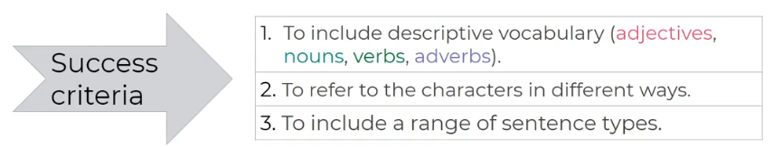

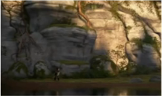
Hiccup enters the valley
___________________________________________
___________________________________________
___________________________________________
________________________________________________________________________________________________________________________________________________________________________________________________________________________________________________________________________________________________________________________________________________________________________________________________________________________________________________________________

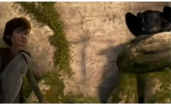
Toothless crouched and watched Hiccup
___________________________________________
___________________________________________
___________________________________________
________________________________________________________________________________________________________________________________________________________________________________________________________________________________________________________________________________________________________________________________________________________________________________________________________________________________________________________________

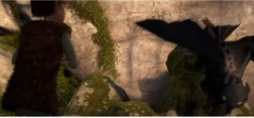
Toothless jumped down from the rock and circles Hiccup
____________________________________
____________________________________
___________________________________________________________________
________________________________________________________________________________________________________________________________________________________________________________________________________________________________________________________________________________________________________________________________________________________________________________________________________________________________________________________________

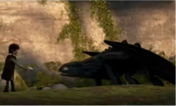
Hiccup offered Toothless the fish _______________________________________
_______________________________________
_______________________________________
________________________________________________________________________________________________________________________________________________________________________________________________________________________________________________________________________________________________________________________________________________________________________________________________________________________________________________________________

