Year 5 English Online Learning – Week 6
Last week you should have written a description for the opening scene of the film/book.
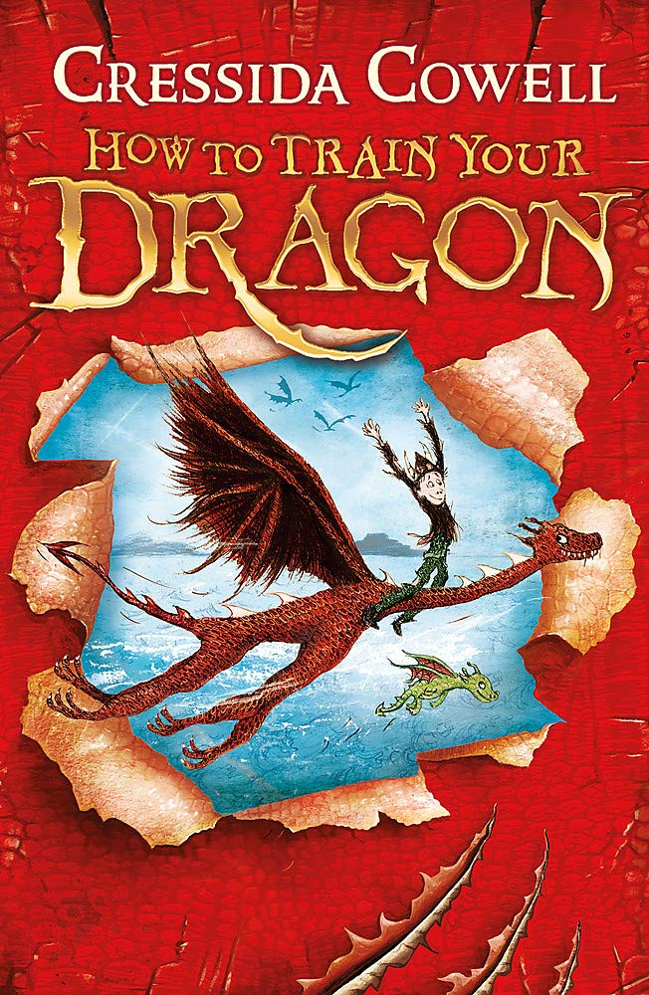
This week, we are going to focus on the build-up scene, which will begin building to the problem of the story. We will generate vocabulary and begin to plan the build-up.
For each of these sessions, there is a teaching video to watch (the links are on the next page). The teacher in the video will explain everything to you and will tell you what equipment you will need (normally, this is only a pen/pencil and piece of paper or a notepad you would like to keep all your English work in). You will need to keep your notes and work from each session as you will use these for the final piece of writing. You must pause the video at the points the teacher asks because you will need to make notes/think/talk to an adult about your ideas. Please don’t worry that the numbers on the video do not match with the numbers ion this document. We are not completing the lessons on spellings so our lesson numbers will be different to the website.
Please send pictures of your notes/piece of work to Miss Hutchinson on the Class 5 email. This could be at the end of the day or at the end of the week.

Monday 8th February 2021
Lesson 9 – Generate adjectives to describe the characters
https://classroom.thenational.academy/lessons/to-generate-vocabulary-to-describe-the-characters-cgt66d
In this lesson, we will think carefully about the characters Hiccup and Toothless. We will generate precise adjectives to describe them and use these to write sentences about them
Tuesday 9th February 2021
Lesson 10 – Explore complex sentences
https://classroom.thenational.academy/lessons/to-explore-complex-sentences-70u66d
In this lesson we will explore complex sentences. We discuss that they are made up of main clauses and subordinate clauses. We will review what these are and then the pupils have a chance to practise writing their own.
Wednesday 10th February 2021
Lesson 11 – To Plan the first part of the opening scene
https://classroom.thenational.academy/lessons/to-plan-the-first-part-of-a-build-up-scene-74upae
In this lesson, we will plan the first section of our writing for the build-up scene in the film 'How to Train Your Dragon'.
Thursday 11th February 2021
Lesson 12 – Develop a rich understanding of words associated with clumsiness
https://classroom.thenational.academy/lessons/to-develop-a-rich-understanding-of-words-associated-with-clumsiness-ctj38t
In this lesson, we will introduce new vocabulary, identify word pairs and synonyms and apply the vocabulary in sentences.

Please keep your notes and ideas from this week as we will continue to write the build-up scene after half term.

