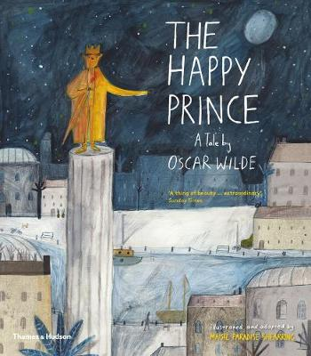
Year 3 and 4 English Online Learning – Week 4
You are now all experts with using the ‘Oak Academy’ resources and videos and this week will see us finishing off our work on ‘The Happy Prince’ which we have been studying for the last five weeks.
During this week, you will be writing the build-up, resolution and ending of the story over three lessons. You will be asked to add speech and to use all of the skills you have learned previously so this will be a great chance to show just how much you have learned. There is no lesson for Thursday as it’s World Book Day!
For each of the sessions on the next page, there is a teaching video to watch. The teacher in the video will explain everything to you and will tell you what equipment you will need (normally, this is only a quiet space in which to work, pen/pencil and piece of paper or a notepad to keep all of your English work in). You will need to keep your notes and work from each session as you will use these for the final piece of writing. You will need to pause the video at the points the teacher asks because you will need to make notes, think or talk to an adult about your ideas.
Please upload your work to Purple Mash as you complete it. We find it more useful if you send your work as you complete it on a daily basis as then we can give you feedback before you start the next lesson.
Miss Moseley and Mr Thompson

Monday 1st March 2021
Lesson 18 – Writing the first part of the build-up
https://classroom.thenational.academy/lessons/to-write-the-first-part-of-the-build-up-61k38c
In this lesson, we will revise our brilliant notes from the previous lesson, have a go at writing the first part of the build up together and check and edit the writing. You will then have a go at writing your own build up of the Happy Prince
Tuesday 2nd March 2021
Lesson 19 – Adding speech to the first part of the build-up
https://classroom.thenational.academy/lessons/to-write-the-second-part-of-the-build-up-with-speech-74w3cr
In this lesson, we will revise how we write speech, write the next part of the build up together, check it and then you will have a go yourself
Wednesday 3rd March 2021
Lesson 20 – Writing the conclusion and resolution of the story (ending)
https://classroom.thenational.academy/lessons/to-write-the-conclusion-and-resolution-to-the-narrative-cgvp4e
In this lesson, we will read the amazing writing that we have done together and think about what happens in the rest of the story. We will look at what action needs to be included and what we should remember when we are writing. Then you will have a go at writing the climax and resolution (the rest of the narrative) yourself! Maybe you will have a book ready to publish and give someone at the end?

