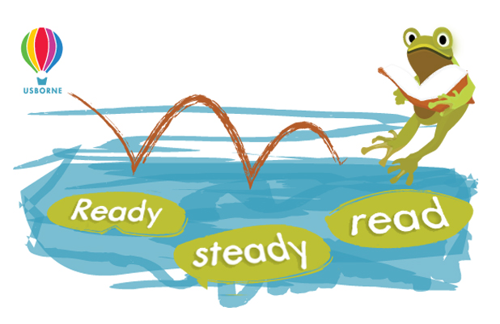

Reading Log

Mill Lane School

Pupil name: ………………………………… Class: …………………….…

Day | Minutes read
Monday
Tuesday
Wednesday
Thursday
Friday
Saturday
Sunday

Total minutes read ………………………………………

Sponsorship Form

Name | Address | Sponsorship  (per minute or total donation) | Amount collected | Total

Total Amount: …………………………

Please return your sponsorship money by Fri 11th March

