Number Walls Transition Project
Aims
The aim of the project is to bridge the gap between Primary and Secondary Mathematics. It is hoped that students will see their work on display in Lord Williams’s and be less daunted as they join a school of 2000 students. In addition to this, we hope that students will develop
- Problem solving strategies
- Systematic methods to tackle a problem and organise a solution
- Reasoning for any conclusions they draw

Outcome
The outcome of the Y6 project is to create an A4 poster demonstrating their findings when exploring number walls and rearranging the base numbers.

Method
The poster can be made on a computer, or by hand. Blank Number Walls from attached PowerPoint may be cut out, filled in and stuck on. An exemplar poster is shown below.
Below is a suggested sheet that you might use to introduce the task to students and a list of questions they might answer. However, the task is meant to be open enough to allow exploration of questions that interest the students.
There are numerous ways in which the task can be extended e.g:
- Look at the number of different ways you can arrange the base numbers
- Change the amount of base numbers you start with
- Fill the number wall algebraically, what would you get if your base numbers were a, b, c, and d.
There is lots of inspiration on the attached PowerPoint.

Assessment
It does not need to be assessed, but should contain the student’s name.

All posters should be sent to Lord Williams’s Lower School by Friday 16th July where it will be stuck up in the Maths Block.
Thank you!
KS3 Mathematics Team
Lord Williams’s School

A number wall begins with only numbers in the bottom row. Bricks in the next row are filled by adding the numbers in the two bricks below. The two number walls shown give different totals for the top brick using the same numbers at the base. Investigate the different totals that the top brick can have by rearranging these base numbers.
- What is the highest total possible?
- What is the lowest total possible?
- How many different possible totals are there?
- Given any 4 base numbers, how would you arrange them to produce the highest/lowest total?

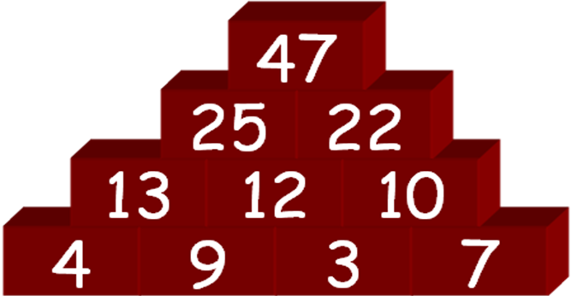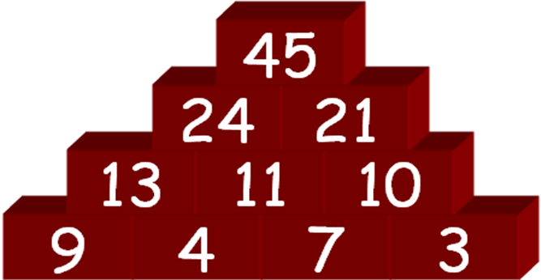

Make a colourful A4 poster showing what you find out.

Given the starting numbers 3,4,7,9, I found out that the biggest total on a number wall you can make is 55. There are 4 different ways of doing it.

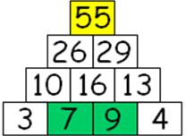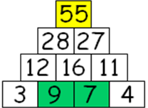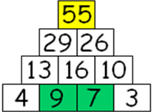

I found out that the smallest total on a number wall you can make given the same starting numbers is 37. There are 4 different ways of doing it.

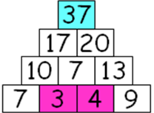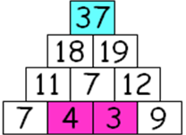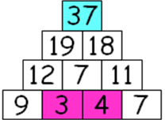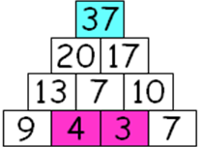

Given any 4 starting numbers, putting the biggest two in the middle will give you the highest total and putting the smallest two in the middle will give you the lowest total.
By Jim Smith
Year 6

