Monday 25th January  Science  L.O: to understand friction as a force  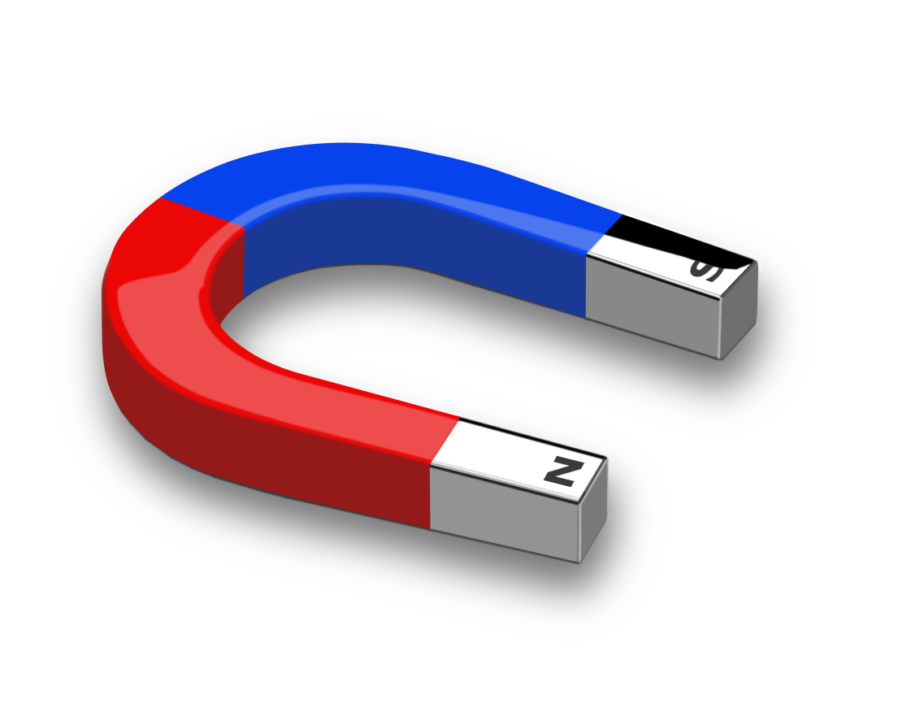 | Today you are going to investigate the following question:  Which materials prevent a paperclip from being attracted to a magnet?  You will need:  - A magnet  - A magnetic paper clip  - 10 objects to place between the paperclip and the magnet, such as your hand, a piece of paper, a book, a table, a cup, a door etc.  Follow the teaching PowerPoint.  If you do not have a magnet, please watch the following video instead:  https://www.bbc.co.uk/bitesize/topics/zyttyrd/articles/zw889qt  When you have watched the video, scroll down and complete the sorting activity. Then have a go at the quiz.  Make a list of some of the magnetic objects as you may be asked about these during your class quiz this week.
Tuesday 26th January  Topic  L.O: to know why the Magna Carta was put into place | 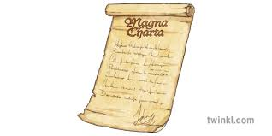  Last week we learned all about the type of character King John was. I think we can all agree, he wasn’t the nicest of characters and was a very mean and greedy king.  Finally in 1214, the Barons (people of the land) put in place the Magna Carta and forced King John to sign it. Today you are going to learn all about the Magna Carta and why it plays an important part in today’s democracy.  What is democracy? Look the definition up in a dictionary; this can be an online one.  Watch the video  https://vimeo.com/122334367  Choose from one of the following tasks:  - Create a poster/fact file all about King John and why the Magna Carta was put into place.  Write your own set of rules for others to follow: for example:  - School rules for your class to follow  - House rules for your family to follow  - Rules for playing with your toys for friends or siblings to follow.  You could dip your paper in teabags to give it an authentic look.
Wednesday 27th January  RE  L.O: to know the Five Pillars of Islam  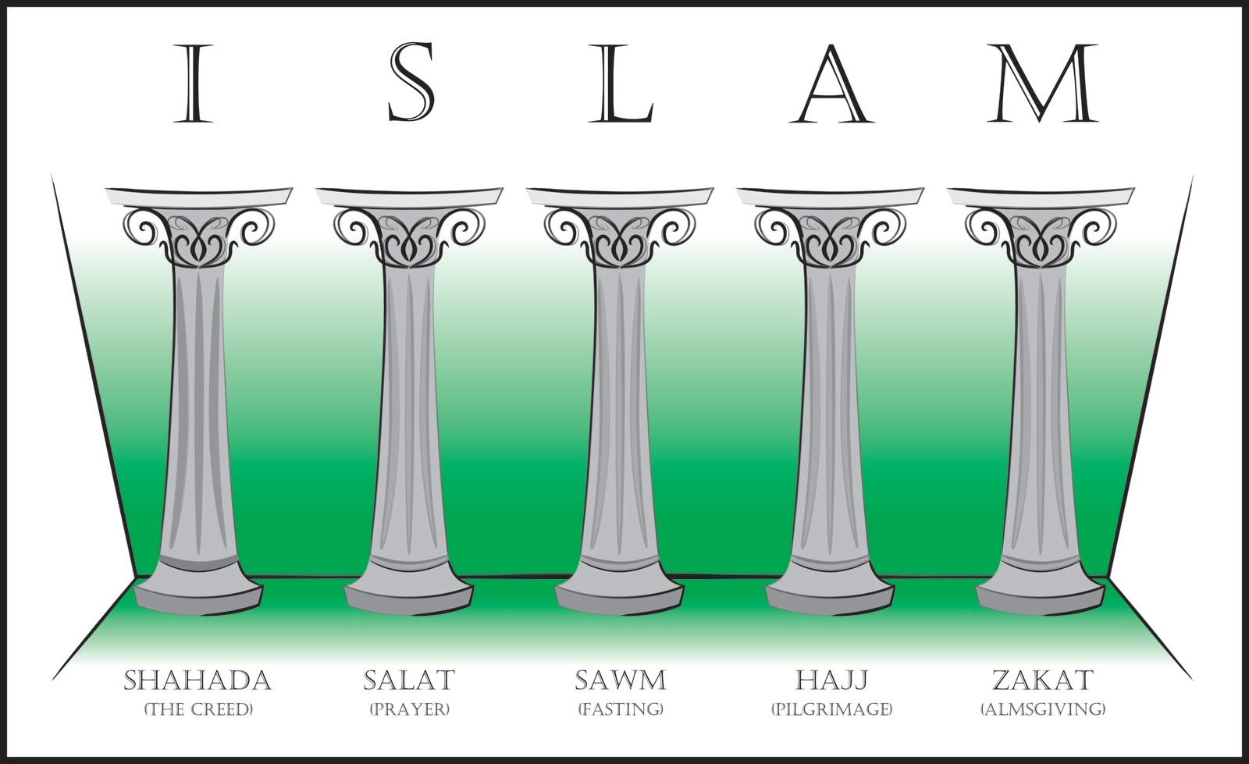 | Last week you learned where and who founded Islam. This week you are going to learn about their main beliefs, known as the 5 Pillars.  Watch the teaching video (LESSON 3) and complete the tasks on the video. (You do not have to do the quiz at the start as you haven’t done the previous lessons. Click next and this will take you to the lesson.  https://classroom.thenational.academy/units/islam-f461  Optional Task: When you have finished the video, choose from one of the following tasks:  - Create a poster about the 5 Pillars  - Draw a picture of each of the 5 Pillars and write a short explanation about each one  - Design your own 5 Pillars – what symbols would they be and why?  Note: Do not draw a picture of Mohammad or any other prophet of Islam. Muslims believe they should not be pictured in any way and it is considered highly disrespectful to the religion. Please be respectful of this belief.
Thursday 28th January  Computing  Researching | Today you are going to research a castle of your choice. You may wish to research a local castle, such as Oxford or Wallingford. Or you may wish to research one of the queen’s residents such as Windsor Castle, or Balmoral Castle. You may have seen a castle on your holidays and want to know more about its history, it is completely up to you.  This activity is to be completed on Purple Mash. Go to your 2dos and complete the activity. You are expected to write at least 3 facts about your castle; you may write more if you wish.
Optional extra lessons | Music: Exploring pulse and Metre  Watch the teaching video. Lesson 1: https://classroom.thenational.academy/units/pulse-and-metre-583c  All you need is your hands, a pencil and paper.  Art and Design: Design your own castle.  You may choose to present this how you wish, such as a drawing, painting, cardboard, model, Lego, or even minecraft.  You castle must have the following features:  - Tower  - Moat  - Drawbridge  - Battlements  - Arrow Loops
