Year 6 Home Learning
King Midas – Greek Mythology
The following document guides you through some activities you could complete linked to the Greek Myth of King Midas. We would have been studying similar myths at school as part of our learning, with a focus on the features of myths, story-telling techniques and debates. The writing in black is information and the blue writing is questions to prompt thought/discussion and ideas for creative activities. This is only a guide and it should not be assumed that every child should complete everything. I do expect that everyone should know the story of King Midas and complete at least two activities linked to it. The ideas for learning that I have provided are not exhaustive. Some children/parents may have their own interests and ideas for activities (linked to the Kind Midas story or other Greek Myths) and it would be great to see unique learning that you have chosen to undertake. I do understand that some children and parents will find this difficult, given the circumstances, however, I do hope that the children will enjoy having a focused set of activities and will enjoy sharing their learning on the ‘King Midas’ Blog page on Purple Mash. Work can also be e-mailed to me as well: class6@mill-lane.oxon.sch.uk
Take care and I look forward to seeing what you have created,
Mrs Carey

King Midas Greek Mythology
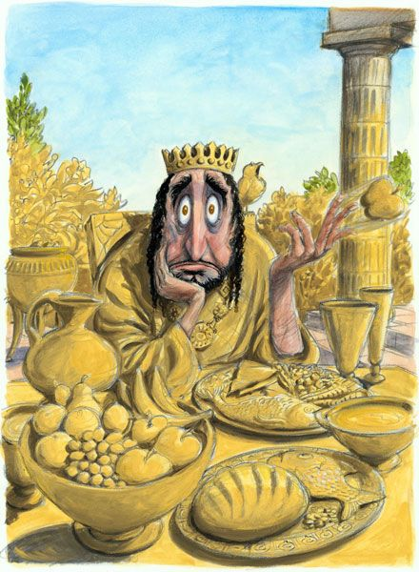
King Midas is popularly remembered in Greek mythology for his ability to turn everything he touched into gold. This came to be called the golden touch, or the Midas touch.
What do you think it would be like to have this special power? Would you enjoy it? Would you like similar powers? What would be good/bad about it? Discuss with a member of your family or post your thoughts on our ‘King Midas’ blog on PurpleMash. You could also create table of reasons ‘for’ and ‘against’ having the power to turn everything you touch into gold. This could then be turned into a written debate. You might have more ideas for this debate after finding out more about the story too.
Another idea at this point would be to write a newspaper reporting at the time the Greek citizens realised their King had a special power. Example headlines include: ‘GOLD EVERYWHERE!’ ‘GREAT GOLDEN TOUCH’. Eyewitness accounts could come from people who work at the palace and claim to have witnessed the King turn objects into gold as well as members of the public giving their opinion about the King’s power.

Read through the story cards or the story print out (pdf documents attached on the Parent Mail) to understand the story. The story can also be found on various websites in video form. This is a simple version of the story: https://www.youtube.com/watch?v=sWcJNvS0J80
Can you re-tell it in your own words to another member of your family using your summary skills? You could create a story map or a story board to help you retell the key events.
Can you re-write the myth in your own way using features of writing we would use at school? (Fronted adverbials, conjunctions, speech, a variety of punctuation). There are some special writing pages that you could print off to write your story onto.
Imagine you are King Midas. You still have your powers and you have realised they are not as good as you think. Write a persuasive letter to Dionysus asking him to take back the powers and return everything back to normal.
Draw a picture of King Midas showing his facial expression as he looks at all the gold objects around him. Think carefully about what feelings he would have – maybe look up some synonyms (similar words) in a thesaurus.
Compare the story with the Skittles Advert: https://www.youtube.com/watch?v=qp0WBiME_fM
Can you rewrite the myth as an alternative version with a modern twist? Steps to help complete this:
- Come up with a modern main character (e.g. you, a celebrity, the Queen…)
- Decide on a dilemma/problem that they will help solve in order to get their special power (e.g. save the world or rid the world of peas which is my least favourite vegetable!)
- Decide what power they will request as a reward (e.g. everything they touch turns into…)
- Have fun thinking about all the things they will convert (the queen could turn her corgi dogs into something silly!)
- Decide how this problem can be solved (will they beg for the powers to be taken away?)
It would be great to see some really creative ideas for your story with illustrations to go with it. Have fun!

If you have enjoyed this myth, you could research further Greek myths online. The BBC have a variety on their website where you can listen to or read the myths: https://www.bbc.co.uk/teach/school-radio/ks2-ancient-greece/zk73nrd

