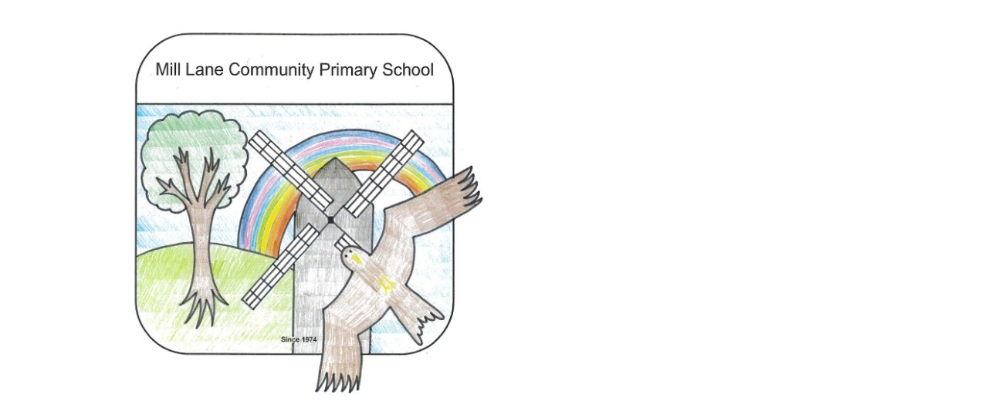
Home Reading Diary

Date | Book Title | Parents Comments
Name ……………………………………………… Class……………………………………

