Oxfordshire County Council
Mill Lane Community Primary School
The Windmill Community Nursery
Mill Lane Chinnor Oxfordshire OX39 4RF
Head Teacher Miss Tineke van der Ploeg
Telephone/fax 01844 352106
e-mail office.2465@mill-lane.oxon.sch.uk

Newsletter

Number 4 Tuesday 26th February 2019

Dear Parents / Carers,

It is hard to believe that we are already half way through the year. It has been a busy time already and we still have lots more planned not only for this term but the rest of the year.

Class Assemblies
We have also had the pleasure of watching 3 class assemblies. The Year 6 children shared work on the Anglo Saxons and the Year 3 & 4 classes shared work on their topic on the Amazon Rainforest. All the assemblies were very different, but they did have one thing in common – they were all very informative and enjoyable to watch. Below are the dates for the remaining class assemblies. All start at 2.30pm:
Class 5 – Friday 8th March
Class 2 – Friday 15th March
Class 1 – Friday 22nd March

I would also like to remind you that we will round off this term with our spring family assembly on Friday 5th April at 1.15pm. School will then close after the assembly at 2.15pm.

Parent Consultations
KS1 and KS2 parents will all receive a mid-year report for their child/children on Friday 1st March. The mid-year report will show whether your child is working at the expected level or whether they are below or above the expected level. The report also highlights what the children’s targets are in literacy and numeracy.
Letters will soon be going out informing you of the next parent consultation evening. It will be held on Monday 18th March 3.30pm – 8.00pm. It will be an opportunity to discuss what was in the midyear reports.

World Book Day
The annual World Book day will take place this year on Thursday 7th March. As usual we will be holding our amazing ‘Book Factor’ competition over the course of this week with the finals being held on the Thursday. We will be holding a mufti day on Thursday 7th and the children must come as a book character that they can name and talk about.

Spring Music Concert
The concert will be held on Wednesday 27th March at 3.30pm. It is a great opportunity for our musicians and singers to perform and show how much progress they have made over the year. There will be more information nearer the time.

Around the World
We will be holding a special themed week based around the title ‘Around the World’. All the classes will be looking in detail at one country and will do a range of activities linked to this country. However, during this week we will also have extra events. We have already booked a Bollywood Dance workshop and we are hiring some Google VR sets so that we can have a virtual tour of the countries we are studying. More information will follow nearer the time.

These are just some of the events we have to look forward to. A full list of key dates is included at the end of this newsletter. We do try to keep to these dates as much as possible but sometimes it can be subject to change.

Attendance
As a school we are concerned by the number of children’s whose attendance is below 90%, so we have yet again included the following information which shows the effect on a child’s education from missing so much school.
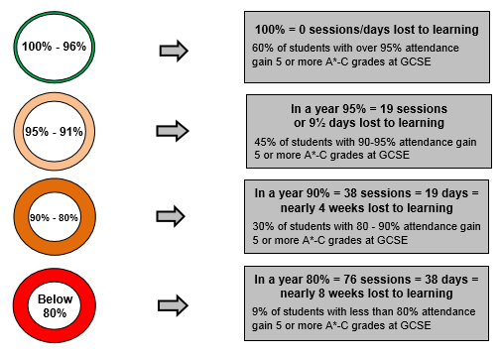

It is important that even children at this young age should get in to the good habit of attending school regularly. Children’s attendance which is below 85% can be subject to an attendance plan which is an agreement between the school and home and sets out expectations of how the child’s attendance will improve. If after this step the attendance does not improve, then it can be referred to County and parents may be taken to court. The school does not want to let it get this far, so please contact the school if you are having problems getting your child to school and we can work together to improve the situation.

Staffing News
As you are probably aware, Mrs Harper is currently on maternity leave enjoying time with her new baby girl. Mrs Harper has decided that she would like to spend more time bringing up her two young daughters before she returns to work so has reluctantly taken the difficult decision to leave Mill Lane. Mrs Harper has been at the school for 12 years having joined as a nervous NQT. She has helped lead the school in to the strong position it is now in and we wish her all the best for the future. We are hoping Mrs Harper will come to our family assembly on the last day of term so that we can give her a proper send off and say goodbye properly.

Yours sincerely,

Tineke van der Ploeg

Diary Dates for Term 4

March
Monday 4th March: Start of book week. Extreme reading entries need to be handed in today.
Wednesday 6th March: 6pm E-Safety parent workshop
Thursday 7th March: World Book Day (Mufti Day)
Thursday 7th March: 2pm Sleep Group starts
Friday 8th March: 2.30pm Class 5 assembly
Monday 11th March: Midyear reports go out
Wednesday 13th March: Year 6 Junior Citizens Trip
Wednesday 13th March: 1pm Girls football tournament
Friday 15th March: Comic Relief Mufti Day
Friday 15th March: Class 2 Assembly
Monday 18th March: 3.30pm – 8.00pm Parent consultations
Thursday 21st & Friday 22nd March: MLSA Mothers day bring and buy sale
Friday 22nd March: 2.30pm Class 1 assembly
Monday 25th March: Start of ‘Around the World’ week
Monday 25th March: Bollywood dance workshops
Monday 26th March: 6pm Year 6 SATs information meeting for parents
Wednesday 27th March: 3.30pm Spring music concert
Monday 1st April: 6pm KS1 SATs evening for parents
Friday 5th April: 1.15pm Family Assembly
Friday 5th April: Last day of term (2.15pm early closing)

We return to school on Wednesday 24th April.

