**Understanding the World**

**People and Communities:** Children talk about past and present events in their own lives and in the lives of family members. They know that other children don’t always enjoy the same things, and are sensitive to this. They know about similarities and differences between themselves and others, and among families, communities and traditions.

**The World:** Children know about similarities and differences in relation to places, objects, materials and living things. They talk about the features of their own immediate environment and how environments might vary from one another. They make observations of animals and plants and explain why some things occur, and talk about changes.

**Technology:** Children recognise that a range of technology is used in places such as homes and schools. They select and use technology for particular purposes.



**Expressive Arts and Design**

**Exploring and Using Media and Materials:** Children sing songs, make music and dance, and experiment with ways of changing them. They safely use and explore a variety of materials, tools and techniques, experimenting with colour, design, texture, form and function.

**Being Imaginative:** Children use what they have learnt about media and materials in original ways, thinking about uses and purposes. They represent their own ideas, thoughts and feelings through design and technology, art, music, dance, role play and stories.



# Mill Lane Community Primary School



**End of Year Expectations**

**For Reception**

This booklet provides a summary of the end of year expectations (Early Learning Goals) for children for reading, writing and mathematics.

All of the Early Learning Goals will be worked on throughout the year and will be the focus of adult-led and child-initiated activities. Any extra support you can provide in helping your children to achieve these is greatly valued.

If you have any queries regarding the content of this booklet or want support in knowing how best to help your child, please talk to your child’s teacher.

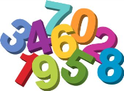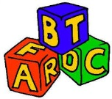

**Communication & Language**

**Listening and attention:** Children listen attentively in a range of situations. They listen to stories, accurately anticipating key events and respond to what they hear with relevant comments, questions or actions. They give their attention to what others say and respond appropriately, while engaged in another activity.

**Understanding:** Children follow instructions involving several ideas or actions. They answer ‘how’ and ‘why’ questions about their experiences and in response to stories or events.

**Speaking:** Children express themselves effectively, showing awareness of listeners’ needs. They use past, present and future forms accurately when talking about events that have happened or are to happen in the future. They develop their own narratives and explanations by connecting ideas or events.

**Literacy**

**Reading:** Children read and understand simple sentences. They use phonic knowledge to decode regular words and read them aloud accurately. They also read some common irregular words. They demonstrate understanding when talking with others about what they have read.

**Writing:** Children use their phonic knowledge to write words in ways which match their spoken sounds. They also write some irregular common words. They write simple sentences which can be read by themselves and others. Some words are spelt correctly and others are phonetically plausible.

**Maths**

**Number:** Children count reliably with numbers from one to 20, place them in order and say which number is one more or one less than a given number. Using quantities and objects, they add and subtract two single-digit numbers and count on or back to find the answer. They solve problems, including doubling, halving and sharing.

**Shape, Space and Measure:** Children use everyday language to talk about size, weight, capacity, position, distance, time and money to compare quantities and objects and to solve problems. They recognise, create and describe patterns. They explore characteristics of everyday objects and shapes and use mathematical language to describe them.

**Personal, Social and Emotional Development**

**Making Relationships:** Children play co-operatively, taking turns with others. They take account of one another’s ideas about how to organise their activity. They show sensitivity to others’ needs and feelings, and form positive relationships with adults and other children

**Self-Confidence and Self-Awareness:** Children are confident to try new activities, and say why they like some activities more than others. They are confident to speak in a familiar group, will talk about their ideas, and will choose the resources they need for their chosen activities. They say when they do or don’t need help

**Managing Feelings and Behaviour:** Children talk about how they and others show feelings, talk about their own and others’ behaviour, and its consequences, and know that some behaviour is unacceptable. They work as part of a group or class, and understand and follow the rules. They adjust their behaviour to different situations, and take changes of routine in their stride.

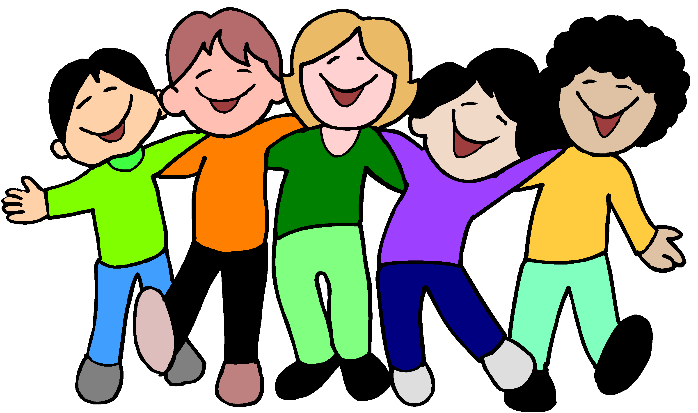

**Physical Development**

**Moving and Handling:** Children show good control and co-ordination in large and small movements. They move confidently in a range of ways, safely negotiating space. They handle equipment and tools effectively, including pencils for writing.

**Health and Self Care:** Children know the importance for good health of physical exercise, and a healthy diet, and talk about ways to keep healthy and safe. They manage their own basic hygiene and personal needs successfully, including dressing and going to the toilet independently

