Year 6 English Online Learning – Week 2
We have focussed so far on narrative writing to write the opening scene and build-up of ‘How to Train your Dragon’. This week we are changing text type to begin writing a set of instructions. We will continue this theme when we are back in school.
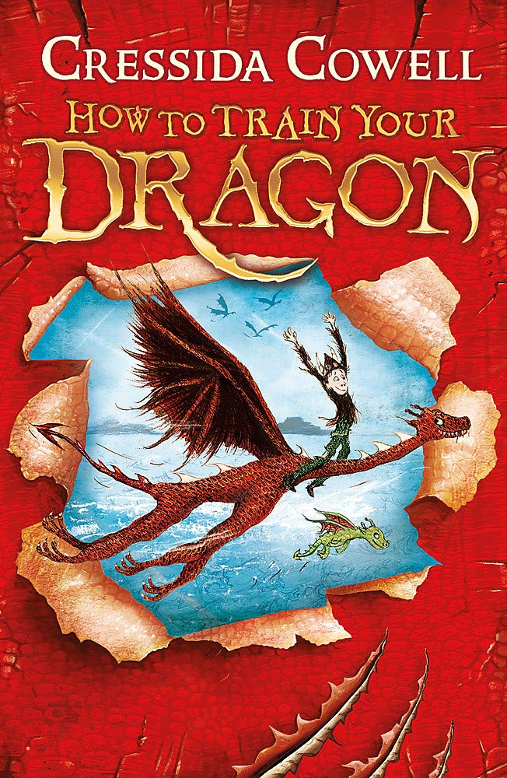
For each of these sessions, there is a teaching video to watch (the links are on the next page). The teacher in the video will explain everything to you and will tell you what equipment you will need (normally, this is only a pen/pencil and piece of paper or a notepad you would like to keep all your English work in). You will need to keep your notes and work from each session as you will use these for the final piece of writing. You must pause the video at the points the teacher asks because you will need to make notes/think/talk to an adult about your ideas. Please don’t worry that the numbers on the video do not match with the numbers on this document. We are not completing the lessons on spellings so our lesson numbers will be different to the website.
Please send pictures of your notes/piece of work to Mrs Carey on the Class 6 email. This could be at the end of the day or at the end of the week. Class6@mill-lane.oxon.sch.uk

Monday 2st March 2021
Lesson 1 – To identify the features of an instructional text.

https://classroom.thenational.academy/lessons/to-identify-the-features-of-an-instructional-text-chgkct
In this lesson, we will look at the features of instructional texts and have a go at identifying some of these features together.
Tuesday 2nd March 2021
Lesson 2 – To revise complex sentences

https://classroom.thenational.academy/lessons/to-revise-complex-sentences-cct34c
In this lesson, we revise complex sentences. We review simple and compound sentences and then discuss what a complex sentence is. We review how to punctuate complex sentences. The pupils then have a chance to practise writing complex sentences.
Wednesday 3rd March 2021
Lesson 3 – To write an introduction
Optional Writing Template available on the website for this lesson.
https://classroom.thenational.academy/lessons/to-write-an-introduction-6njpae
In this lesson, we will identify the purpose of an introduction to instructions and have a go at writing our own introduction for our instructions on how to care for a pet dragon!
Thursday 4th March 2021
World Book Day

World Book Day themed activities from the menu

