All about Greece!

Your English writing challenge for the next two weeks is a little bit different. You need to present a non-fiction (information/fact) text about Greece. It is your choice whether you would like to write it about modern Greece or about Ancient Greece.
This could be a travel brochure offering information about sights for tourists visiting Greece. It could be a poster persuading people to visit Greece. If you are getting really creative, it could be a written script which you perform and record as a travel advert for radio or TV, giving details about what there is to see in Greece. You might need to do some research into what a good one looks like. Have a look on holiday travel sites and see how they advertise different destinations for ideas. It could also be an information text about different aspects of Ancient Greek life. It could include sections that you choose to research e.g. Ancient Greek food, Ancient Greek jewellery, Life for Ancient Greek Children etc.
The following websites provide ideas of places you can find research about Greece:
https://www.sciencekids.co.nz/sciencefacts/countries/greece.html
http://www.primaryhomeworkhelp.co.uk/greece/today.html
These websites provide excellent information about Ancient Greece:
https://www.bbc.co.uk/bitesize/topics/z87tn39
https://www.historyforkids.net/ancient-greece.html
https://www.ducksters.com/history/ancient_greece.php
This is a very open ended task but you must produce something that is non-fiction (factual). If you need any guidance or further ideas, please do not hesitate to contact me. Below is a guide to writing non-fiction texts as a helpful reminder. You may be able to include a lot of the features.
Good luck and I look forward to seeing how you tackle this challenge!
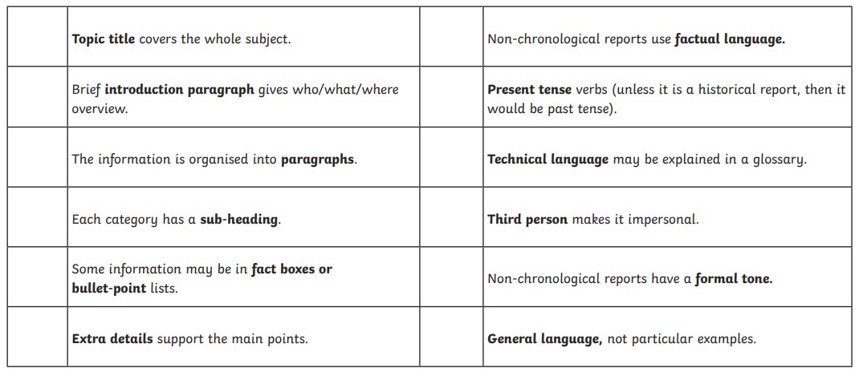
Mrs Carey,

