Choose your homework from the menu below. This is in addition to weekly spellings and maths homework. You should aim to complete 4 pieces of work from this list, however, you could do more if you would like to! The ‘Peri-ometer’ colour chart suggests the difficulty or challenge each task may offer. These are just ideas – if there is an area of our topic that really interests you, please feel free to adapt the homework activity.
Science – Animals including Humans  Describe the ways in which nutrients and water are transported within animals, including humans. This could be an explanation, poster, PowerPoint – be creative! | Make a travel brochure about Ancient Greece Where would you travel to? Where would you stay? What could you do while you were there? Who would you recommend to visit? Use pictures with lots of facts and information. | Create your own Olympics – plan the sporting events you could do and set it up in your garden/park! Take photos or write about what you did. | Make a Spartan helmet of design and Make a Spartan shield.
Science – Animals including Humans  Create a family tree or research some family history (you could call or skype your relatives to ask them questions). Look at photos to see how humans change as they get older. | Write a diary extract from the viewpoint of a family member in Sparta or in Ancient Greece. Try to write about your feelings about daily life. You could research what life was like as a child | Draw and label a map of Greece and plan a trip there. Which modes of transport would you use to get there from your house? Which countries would you pass through or over? | Create a picture of an imaginary Greek God. Make sure your poster is eye-catching and full of facts and information. Try to think of a symbol for your God.
Science – Animals including Humans  Find out about the lifecycle of an animal of your choice. Decide how you would like to present this information. | Turn a myth into a cartoon,  for example:  Theseus and the Minotaur.  Use lots of speech bubbles. | Make a set of Top Trump cards about the Greek Gods. | Research Ancient Greek architecture (building designs).  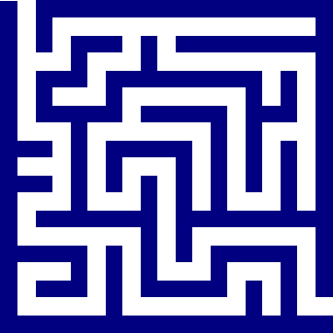  Can you re-create any buildings supported by columns? You could use anything around your house or garden and take a picture.
Science – Animals including Humans  Create a fact file about an animal of your choice. You could look at its adaptations and special features. As a challenge, you could create a new animal and think about how it would be adapted to its surroundings to survive. | Research Greek food – make some if possible and record your Greek food restaurant menu or recipes. | It’s all Greek to me! Find out some simple Greek phrases. E.g. Hello, How are you? What’s your name? Etc. Can you make a poster to display them in Greek & English? Make sure you can pronounce them correctly and teach them to the class! | Design your own Labyrinth.  It could be made of straws, string or wood.

