Mill Lane Community Primary School
Forest School

Our Vision

‘Forest School is an inspirational process, that offers ALL learners regular opportunities to achieve and develop confidence and self-esteem through hands on learning experiences in a woodland or natural environment with trees’ (The Forest School Association).

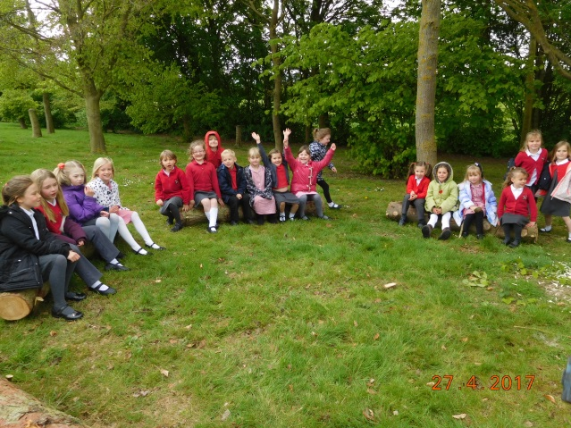
Forest School at Mill Lane will encourage independent, enthusiastic, and creative learners who will develop holistically through a well-planned child initiated approach. Through carefully planned activities, students from all year groups at the school will take part in Forest School work throughout the year which enables them to excel in all areas of their personal, academic and spiritual development.

There are 6 key principles to Forest School.

- Forest School is a long term process of frequent and regular sessions over an extended period of time. At Mill Lane each child will have a 6 week block of Forest School sessions held on Wednesday afternoons.

- Forest School session will take place in a woodland or a setting with trees. At Mill Lane we are lucky to have such a wonderful outdoor area including a wildlife area; Gruff Land, a large pond, a meadow area encouraging butterflies and bees as well as a large field including many trees.

- Forest School promotes holistic development for all those involved. Instead of breaking down development into separate areas, the Forest School approach focuses on all areas of development at the same time. We aim to foster resilient, confident, independent and creative learners.

- Forest School provides opportunities for participants to take supported risks. Mill Lane will give children the opportunities to explore and interact with their environment so they can learn to keep themselves safe. We will provide risky activities such as the use of tools and fire.

- Forest School is led by trained and qualified Forest School practitioners this ensure the principles and practices of Forest School are followed. At Mill Lane all Forest School sessions will be directed by a Level 3 Forest School Leader.
.
- Forest School employs a learner centred approach. The pedagogy of Forest School is based on child led learning where the activities are initiated by the learner rather than dictated by the leader and/or curriculum.

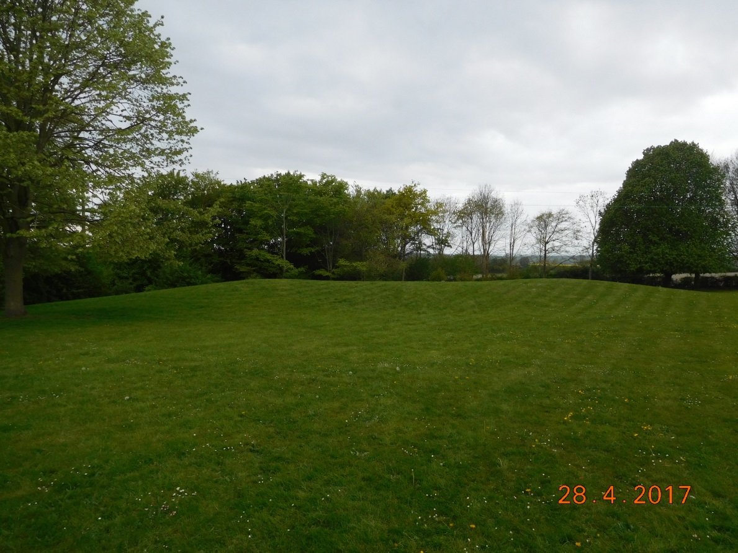

Reviewed: September 2018

Next Review: September 2019

